Configuring Permissions

Exercise 1: Investigation

Answer the following questions using the Security Dictionary.

1. All of the system permissions which pertain to activities start with the letters "act". How many system permissions are there that pertain to activities?
2. Are the activity system permissions all static, all object-based, or are there some of each?
3. What is the name of the system permission a user must have to own an activity? How many roles is this permission currently assigned to?
4. How many permissions are associated to the Catastrophe Admin role?
5. There are five application permission keys which pertain to notes. Which one has the largest number of system permissions?
6. There are five application permission keys which pertain to notes. Which one is static?
7. VoidStopCheck is a page in the user interface. Are any permissions needed to view the page? To edit it?

Exercise 2: Configuration

Configure ClaimCenter to meet the following customer requirement from Acme Insurance.

**Requirement**

In the base application, any adjuster can add, modify, or remove metropolitan (police) reports, which appear at the bottom of the loss details page. Acme Insurance wants to modify the application behavior so that only supervisors can remove existing reports. For the time being, they only want this restriction for the Auto LOB.

1. Create a custom permission which will be used to control a user's ability to remove metropolitan reports.
2. Add the system permission to the Claim Supervisor role.
3. Modify the user interface so that the Remove button at the top of the metro report list is visible only to users with the new permission.

**Test Case**

When you have completed your configuration, run the following test cases:

1. Log on to ClaimCenter as Andy Applegate, who is not a manager or supervisor. Navigate to any Auto claim. Put the Loss Details screen into Edit mode. Then, verify that he can add, but cannot remove metropolitan reports.

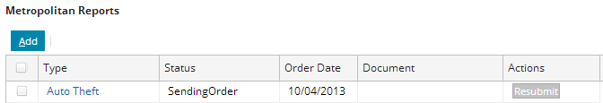

1. Log on to ClaimCenter as Sue Smith, who has the Claims Supervisor role. Navigate to the same claim. Put the Loss Details screen into Edit mode. Then, verify that she can remove metropolitan reports.
2. This may only be possible when the report status is still “New”. If the status is not "New", then the remove button is visible but not available.  This is the case because the widget has a property called "removeFlags" which controls the availability of the remove button.

